Basically, this mode will activate strictly type mode kind of. This strict context prevents certain actions from being taken and throws more exceptions.



Some of the things that will throw error in strict mode:

* Using an object, without declaring it, is not allowed



* The string **“eval” “arguments”** cannot be used as a variable





* Deleting a variable (or object) and a function is not allowed.

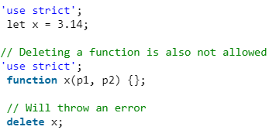

* Duplicating a parameter name is not allowed.



* Octal numeric literals are not allowed.



* Escape characters are not allowed.



* Writing to a read-only property is not allowed

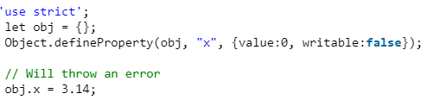

* Writing to a get-only property is not allowed

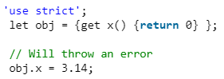

* Deleting an undeletable property is not allowed



* The with statement is not allowed.

